

**Project Report on**

Food Heist

### BY

**18MCA034 Gayatri Niranjan Mahana**

**18MCA030 Nikita Kriplani**

**18MCA023 Finny Jose**

Under the guidance of

**"Prof. Dr. Minesh Ade"**

**(Academic Year: 2019 – 2021)**

**IN PARTIAL FULFILLMENT OF**

**MCA 6010 / Mini Projects**

**As prescribed by MITWPU**

**Dr. Vishwanath Karad MIT-World Peace University’s**

**School of Management (PG)**

**Pune**

CERTIFICATE

This is to certify that Ms. **Gayatri Niranjan Mahana** and **Ms. Nikita Kriplani** Of MIT-WPU’s School of Management (PG) have successfully completed the project report titled Student Portal in partial fulfilment of requirement for **MCA 6010/Mini project** asprescribed by the Dr. Vishwanath Karad **MIT-World Peace University**.

This Report is the record of authentic work carried out during the academic year 2019-21.

|  |  |  |  |
| --- | --- | --- | --- |
| **Prof. Minesh Ade**  **Internal guide** | Prof. Ashish Kulkarni | Prof. Dr. T. J. Vidyasagar  Head of School  MITWPU School of Management | Prof. Dr. Sayalee Gankar  Dean  MITWPU School of Management |

Date:

Place:

Examined by:

Examiner 1

Examiner 2

DECLARATION

We, Ms. Gayatri Niranjan Mahana and Ms. Nikita Kriplani hereby declare that this Research Report is the record of authentic work carried out by us during the academic year 2019-20 and has not been submitted to any other University or Institute towards the award of any degree.

|  |  |  |
| --- | --- | --- |
| **Roll No.** | **Name** | **Sign** |
| **18MCA034** | **Gayatri N Mahana** |  |
| **18MCA030** | **Nikita Kriplani** |  |
| **18MCA023** | **Finny Jose** |  |

**Table of Contents**

|  |  |  |
| --- | --- | --- |
| Sr. No. | Content | Page No. |
| **1.** | **Introduction:** |  |
|  | 1.1 Existing System |  |
|  | 1.2 Need for system |  |
|  | 1.3 Scope of work |  |
|  | 1.4 Detail Description of Technology Used |  |
|  | 1.5 Operating Environment Hardware and software |  |
| **2.** | **Proposed System:** |  |
|  | 2.1 Proposed system |  |
|  | 2.2 Objective of a system |  |
|  | 2.3 User Requirement |  |
| **3.** | **UML Diagram:** |  |
|  | 3.1 Use Case Diagram |  |
|  | 3.2 Sequence Diagram |  |
|  | 3.4 Class Diagram |  |
| **4.** | **Tables:** |  |
|  | 4.1 Table Design |  |
|  | 4.2 Table Specification |  |
|  | 4.3 Screenshots with data |  |
| **5.** | **Drawbacks and Limitations** |  |
| **6.** | **Proposed Enhancements** |  |
| **7.** | **Conclusion** |  |
| **8.** | **Bibliography** |  |
|  |  |  |
|  |  |  |

1. **Introduction**
2. **INTRODUCTION**

The traditional system is a restaurant paper menu and ordering system is replaced with an electronic medium i.e. a digital tablet.

Due to a digitalized system, the risk of manual errors is eliminated, thus eliminating the communication barrier.

The tablet displays all the information the customer needs to know about the order he has placed.

This self-service fast food restaurant will be equipped with a user-friendly touch screen, acredit/debit card reader, and software for completing the process at the backend.

For this system there will be a system administrator who will have the rights to enter the menu with their current prevailing prices.

Admin can enter anytime in the system by a secured system password to change the menu contents by adding or deleting an item or changing its price

Now when the customer enters the restaurant, he will place his order with the help of the touch screen using the intuitive graphical user interface till the payment confirmation.

He will select from the food options according to his choice and the system will display the payment amount he has to make once he has finished with his order.

* 1. **Existing System**

The current system is paper based.

Papers are used in restaurants for displaying the traditional menu cards, writing down the orders of customers, storing the records of customers.

**1.2 Need for System**

The disadvantages of paper based system are that papers can get easily damaged by stain marks; they can be lost due to fire or accidents or can get lost in general. Hence, time and money is wasted.

As traditional menu cards are paper based, any changes that need to be made in the menu will require reprinting of the entire menu card, leading to wastage.

For small changes, reprinting the entire menu card is impossible. Changes in the menu card cannot be made dynamically. It is inefficient to access a particular record from the stack of papers. This system is time consuming.

One has to call a waiter number of a time till he notices it, and wait for him to arrive at their table to take their order. Also the waiter can misinterpret the customer’s order since he is waiting the order on paper, and the case of serving a wrong dish is possible.

**1.3 Scope of work**

The online maid service is target to the Indian citizen and also to the registered maid agencies. The scopes of this system are:

1. Customer
   1. Emphasize customer to search food and also can view menu
   2. Enable customer confirmation status from chef.
   3. Enable customer to order interested food via order or account itself.
   4. Enable the customer to view all advertisements which are released by the app.
2. Restaurant manager
   1. Enable App to register and make a list of the available food with it’s price through this app.
   2. Enable app to maintain food detailed information.
   3. Enable app to view customer who apply for the available food and send them food confirmation status.

**1.4 Operating Environment**

**Software Requirements:**

* Android Studio
* MySql

**Hardware Components:**

* RAM: 4 GB or above.
* Hard disk: Minimum 4 GB free space.
* Android phone

**1.5 DETAIL DESCRIPTION OF TECHNOLOGY USED**

**Android Studio** **:**

**Android Studio** is the official [integrated development environment](https://en.wikipedia.org/wiki/Integrated_development_environment) (IDE) for [Google](https://en.wikipedia.org/wiki/Google)'s [Android](https://en.wikipedia.org/wiki/Android_(operating_system)) [operating system](https://en.wikipedia.org/wiki/Operating_system), built on [JetBrains](https://en.wikipedia.org/wiki/JetBrains)' [IntelliJ IDEA](https://en.wikipedia.org/wiki/IntelliJ_IDEA) software and designed specifically for [Android development](https://en.wikipedia.org/wiki/Android_software_development). It is available for download on [Windows](https://en.wikipedia.org/wiki/Windows), [macOS](https://en.wikipedia.org/wiki/MacOS) and [Linux](https://en.wikipedia.org/wiki/Linux) based operating systems. It is a replacement for the [Eclipse Android Development Tools](https://en.wikipedia.org/wiki/Eclipse_(software)#Android_Development_Tools) (ADT) as the primary IDE for native Android application development.

Android Studio was announced on May 16, 2013 at the [Google I/O](https://en.wikipedia.org/wiki/Google_I/O) conference. It was in early access preview stage starting from version 0.1 in May 2013, then entered beta stage starting from version 0.8 which was released in June 2014. The first stable build was released in December 2014, starting from version 1.0.

Since May 7, 2019, [Kotlin](https://en.wikipedia.org/wiki/Kotlin_(programming_language)) is Google’s preferred language for Android app development. Still, other programming languages are supported by Android Studio, such as Java and C++.

**Flutter :**

**Flutter** is an [open-source](https://en.wikipedia.org/wiki/Open-source_software) [UI](https://en.wikipedia.org/wiki/User_interface) [software development kit](https://en.wikipedia.org/wiki/Software_development_kit) created by [Google](https://en.wikipedia.org/wiki/Google). It is used to develop applications for [Android](https://en.wikipedia.org/wiki/Android_(operating_system)), [iOS](https://en.wikipedia.org/wiki/IOS), Windows, Mac, Linux, [Google Fuchsia](https://en.wikipedia.org/wiki/Google_Fuchsia) and the web.

The first version of Flutter was known as codename "Sky" and ran on the [Android](https://en.wikipedia.org/wiki/Android_(operating_system)) operating system. It was unveiled at the 2015 [Dart](https://en.wikipedia.org/wiki/Dart_(programming_language)) developer summit, with the stated intent of being able to [render](https://en.wikipedia.org/wiki/Rendering_(computer_graphics)) consistently at 120 [frames per second](https://en.wikipedia.org/wiki/Frame_rate). During the keynote of Google Developer Days in Shanghai, Google announced Flutter Release Preview 2 which is the last big release before Flutter 1.0. On December 4, 2018, Flutter 1.0 was released at the Flutter Live event, denoting the first "stable" version of the Framework. On December 11, 2019, Flutter 1.12 was released at the Flutter Interactive event, it was announced that Flutter was the first UI platform designed for [ambient computing](https://en.wikipedia.org/w/index.php?title=Ambient_computing&action=edit&redlink=1).

1. **PROPSED SYSTEM**

**2.1 PROPSED SYSTEM**

* The proposed system helps in many ways. It helps to do billing very easily. Account maintenance also becomes easier.
* They can keep track of their purchases of inventories, staffs details, customer feedback, sales of foods, and account details etc.
* The software is provided with the facilities to find out the favorite food of the customers, and the seasonal foods, or customers to add or modify and delete their feedbacks and suggestions.
* It helps in managing data of different types of orders like party order, home delivery or the normal order.
* Managing data of daily customers, managing data of staffs, managing data of daily expenses. It eliminates the drawbacks of existing system and also includes some more features.

**2.2 OBJECTIVE OF SYSTEM**

The general objectives of the study is to develop a reliable, convenient and accurate Ordering System.

* The study has the following specific objectives:
* To develop a system that will surely satisfied the customer service.
* To design a system able to accommodate huge amount of orders at a time.
* To evaluate its performance and acceptability in terms of security, user-friendliness, accuracy and reliability.
* To improve the communication between the client and the server and minimize the time of ordering.
* To automatically compute the bill.
  1. **ANALYSIS OF SYSTEM**
* System analysis is a process of gathering and interpreting facts, diagnosing problems and the information and the information about the app to recommend improvements on the system.
* It is a problem solving activity that requires intensive communication between the system users and system developers. System analysis or study is an important phase of any system development process.
* System analysis is concerned with becoming aware of the problem, identifying the relevant and decisional variables, analysis and synthesizing the various factors and determining an optimal or at least a satisfactory solution or program of action.
  1. **FEASIBILITY STUDY**

A feasibility study assesses the operational, technical and economic merits of the proposed project. The feasibility study is intended to be a preliminary review of the facts to see if it is worthy of proceeding to the analysis phase. From the systems analyst perspective, the feasibility analysis is the primary tool for recommending whether to proceed to the next phase or to discontinue the project.

The feasibility study is a management-oriented activity. The objective of a feasibility study is to find out if an information system project can be done and to suggest possible alternative solutions.  
Projects are initiated for two broad reasons:

* Problems that lend themselves to systems solutions
* Opportunities for improving through:

(a) Upgrading systems

(b) Altering systems

* 1. **USER REQIREMENT**

The main users of this system will be the owner and operators who are registered on the system.

Every user should be:

* Comfortable for working with computer.
* Must have knowledge of working of software.

1. **ANALYSIS AND DESIGN**

**3.1 USE CASE DIAGRAM**

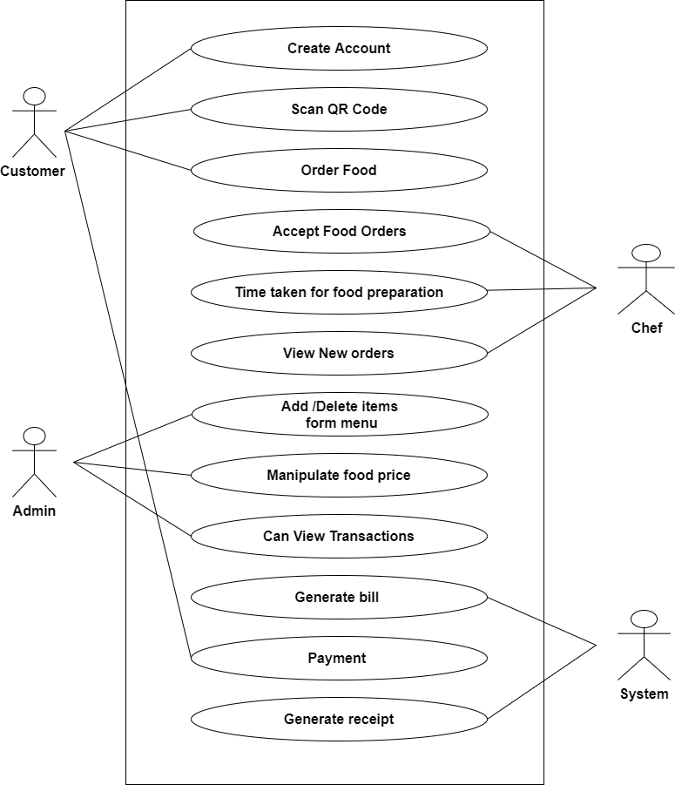

**Fig 3.1: USE CASE DIAGRAM**

**3.2 ACTIVITY DIAGRAM**

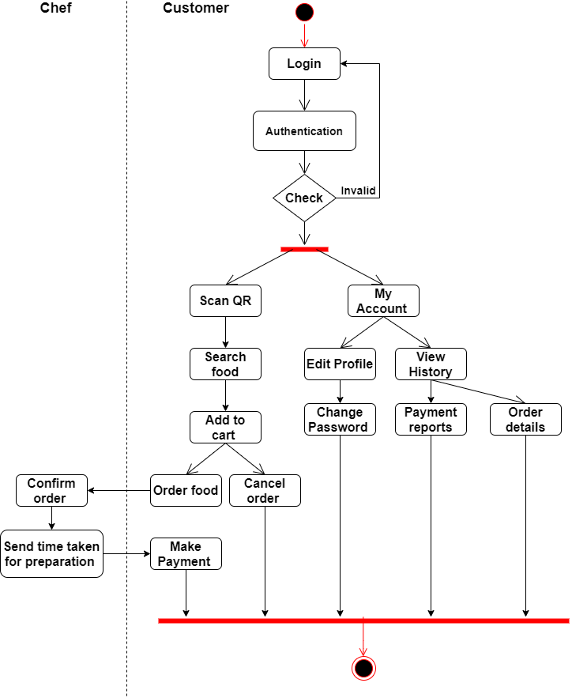

**Fig 3.2 : ACTIVITY DIAGRAM FOR USER**

**3.3 SEQUENCE DIAGRAM**

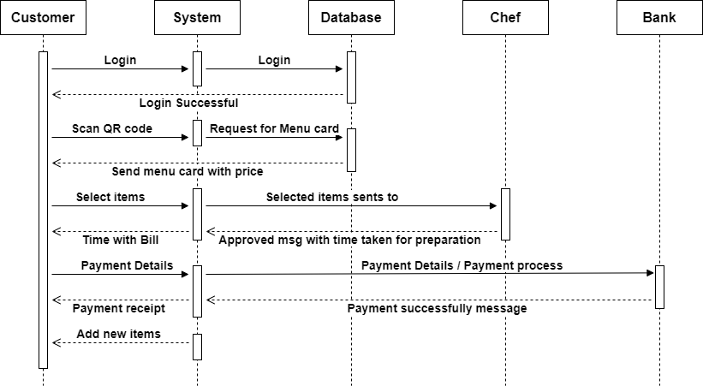

**Fig 3.3 : SEQUENCE DIAGRAM FOR USER**

**3.4 COMPONENT DIAGRAM**

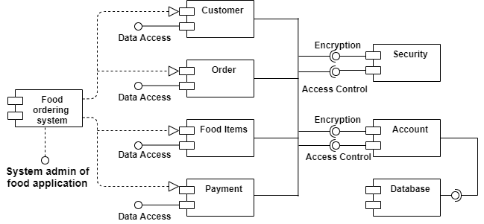

**Fig 3.4 : COMPONENT DIAGRAM**

**3.5 MODULE SPECIFICATIONS**

* Member (future customer of the app) – To register on the Application , to search for food availability, to enter the Order to check the status of the request at any time.
* Chef – To Register and work.
* Administrator/Manager – To manage the application.
* Visitor – To search for food.

1. **USER MANUAL**
   1. **USER MANUAL**

**Customer**

* The user should register first then he can log in to the restaurant. After successful login, he can order the food in that particular restaurant.
* He should be able to see the menu items uploaded by the admin.
* He should select the food required from the admin and quantity.
* Then order option, after this he should enter the payment option,
* Finally, order food option.
* After booking he should be able to see the status of the booking like “your order will be received in 30 minutes”
* Feedback system for the user

**Admin of the Restaurant**

* Admin should log in and he can upload the menu items like North, south and Chinese and in that he should upload the name of the food item, image, price.
* And admin should be able to manage the food orders from the users.
* Feedback system management.

1. **DRAWBACKS AND LIMITAIONS**

* This software is basically used only for reservation means table booking. So if we want to just order some food or store any feed backs then it want be any helpful. At last the restaurants have to store by themselves which will became no use of software.
* The user interface of the application is also not that much attractive. It is made in .net so the restaurant must have to install any windows operating system to install this application.
* So from the restaurants point of view, they are able to store only one kind of information. There is no security feature also.
* If any of party order is cancelling at the last moment, it will make a variation in the already created records and also will causes the wastage of foods.
* Many of the systems will not store the budget details for a long time.
* This will creates lot of mistakes like misspellings, calculation problems, duplicate entries etc.
* It is difficult for Managers to supervise all the sides of restaurants like kitchen, floor, and counter simultaneously.
* There is no functionality to get the updated details at all time to the Owners and Managers from all the branches.

1. **CONCLUSIONS**

Here the need for tablet food ordering is analyzed and its advantages over the traditional food ordering system in restaurants are studied. The proposed online restaurant management system is time saving and error free as compared to the traditional system. This system attracts customers and also adds the efficiency of maintaining the restaurant’s ordering and billing. Hence it is the modern way to grow up the business using Ecommerce. Here implementation of an advanced restaurant menu ordering system using smart android mobile phone. This system entirely reduces the unnecessary time.

1. **BIBLIOGRAPHY**

[**www.google.com**](http://www.google.com)

[**www.youtube.com**](http://www.youtube.com)